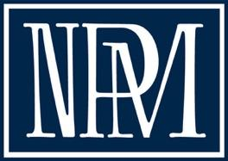
National Association of Pastoral Musicians
NPM Cantor Trainer Application

Date:
Name:
Address:

Email :
Phone:
Parish:

Date of final completion of CCC requirements, and location of vocal adjudication:

Name, email address, and position of the person who will complete your recommendation form:

Briefly share the reasons for your interest in completing this certificate and how it will serve you in your ministry:

Please submit your application to Dee Kittany at: ultimalto@aol.com

